SAFETY DATA SHEET

TRUBAC POTWASH/SANITISER

Data Sheet No. B1 page 1/3

1 IDENTIFICATION OF THE SUBSTANCE / PREPARATION AND THE COMPANY

Product name: TRUBAC 1 POTWASH/SANITISER
Distributer: NERCON LTD
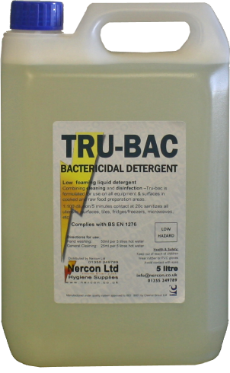
Address: 26/28 SINGER ROAD
EAST KILBRIDE
GLASGOW
UK
G75 0XS

Email: info@nercon.co.uk
Web: www.nercon.co.uk
Telephone: 01355 249789

2 HAZARDS IDENTIFICATION.

Main hazards: No Significant Hazard

3 COMPOSITION / INFORMATION ON INGREDIENTS.

Hazardous ingredients:
Conc. CAS EINECS Symbols/Risk phrases
Coco alkyl dimethylbenzyl ammonium chloride 1-10% 68424-85-1 263-080-8 C; R34 Xn; R21/22 N; R50
Fatty Alcohol Ethoxylate.. 1-10% 68439-45-2 Xn; R22 Xi; R41

4 FIRST AID MEASURES

Skin contact: May cause irritation to skin.
Wash off immediately with plenty of soap and water.
Remove contaminated clothing.
Seek medical attention if irritation or symptoms persist.

Eye contact: May cause irritation to eyes.
Rinse immediately with plenty of water for 15 minutes holding the eyelids open. Seek medical attention if irritation or symptoms persist.

Ingestion: May cause irritation to mucous membranes.
DO NOT INDUCE VOMITING.
Seek medical attention if irritation or symptoms persist.

SAFETY DATA SHEET

TRUBAC POTWASH/SANITISER

Data Sheet No. B1 page 2/3

5 FIRE FIGHTING MEASURES

Extinguishing media: Use extinguishing media appropriate to the surrounding fire conditions.
Fire hazards: Burning produces irritating, toxic and obnoxious fumes.
Protective equipment: Wear suitable respiratory equipment when necessary.

6 ACCIDENTAL RELEASE MEASURES

Environmental precautions: Do not allow product to enter drains.
Prevent further spillage if safe.
Clean up methods: Absorb with inert, absorbent material.
Transfer to suitable, labelled containers for disposal.
Clean spillage area thoroughly with plenty of water.

7 HANDLING AND STORAGE

Handling: Avoid contact with eyes and skin.
Adopt best Manual Handling considerations when handling, carrying and dispensing.
Storage: Keep in a cool, dry, well ventilated area.
Keep containers tightly closed.
Store in correctly labelled containers.

8 EXPOSURE CONTROLS / PERSONAL PROTECTION

Hand protection: Chemical resistant gloves (PVC)
Eye protection: In case of splashing wear: Approved safety goggles.

9 PHYSICAL AND CHEMICAL PROPERTIES

Description: Liquid.
Colour: Yellow.
Odour: Characteristic.
Boiling point: 100°C

10 STABILITY AND REACTIVITY

Stability Stable under normal conditions.

Conditions to avoid: Heat.
Direct sunlight.
Do NOT allow to freeze.

SAFETY DATA SHEET

TRUBAC POTWASH/SANITISER

Data Sheet No. B1 page 3/3

11 TOXICOLOGICAL INFORMATION

Toxicological information: No Significant Hazard.

12 ECOLOGICAL INFORMATION

Do not flush into surface water.

13 DISPOSAL CONSIDERATIONS

General information: Dispose of in compliance with all local and national regulations.

14 TRANSPORT INFORMATION

Further information: The product is not classifed as dangerous for carriage.

15 REGULATORY INFORMATION

Risk phrases: NSH - No Significant Hazard.

16 OTHER INFORMATION

Text of risk phrases in Section 3.

R21/22 - Harmful in contact with skin and if swallowed.
R22 - Harmful if swallowed.
R34 - Causes burns.
R41 - Risk of serious damage to eyes.
R50 - Very toxic to aquatic organisms.

Further information:

The information supplied in this Safety Data Sheet is designed only as guidance for the safe use, storage and handling of the product. This information is correct to the best of our knowledge and belief at the date of publication however no guarantee is made to its accuracy. This information relates only to the specific material designated and may not be valid for such material used in combination with any other materials or in any other process.

Manufactured in the UK by: Cleenol Ltd

